Cancer Treatment Breakthrough: Researchers Engineer A Way To Make Leukemia Cells Kill Each Other
Oct 21, 2015 11:19 AM By Ali Venosa
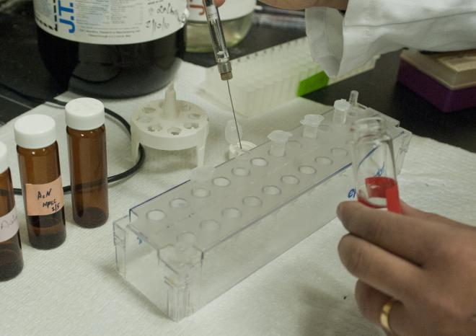
Laboratory results for a possible new therapy were promising
Researchers have been battling to find the cure for cancer since we began to understand what cancer really was. A cure is the ultimate goal, but most medical professionals and patients would be ecstatic even hearing about new treatments. Current cancer treatments often come rife with side effects so severe that many choose to forgo them altogether. Stopping the growth of malicious cancer cells is the main goal of treatment, and removing them altogether is even better. The problem is, this kind of treatment almost always causes damage to surrounding healthy cells.
A treatment that changes cancerous cells into healthy, supportive cells sounds ideal. Transforming malignant cells into antibodies that would attack remaining cancer cells sounds too good to be true. Thanks to a groundbreaking study by scientists at The Scripps Research Institute (TSRI), this new, powerful form of cancer therapy could really be on the horizon.

An Accidental Discovery
The laboratory team was working on therapies for certain immune cell or blood factor deficiencies when they noticed some unusual effects of antibodies on marrow cells. They had been searching for antibodies that activate growth-factor receptors on immature bone marrow cells, meaning the antibodies would be able to induce these cells to mature into specific blood cell types.
After successfully identifying a number of antibodies that activated the bone marrow cell-receptors this way, the researchers noticed that some of the antibodies were having unexpected effects on the cells. Some of them were maturing into cells that were radically different from what had been expected, such as neural cells. This got the team thinking, could this method be used to convert cancerous marrow cells (leukemia cells) into non-cancerous cells?

Transformation
In the new study, Richard A. Lerner, institute professor and the Lita Annenberg Hazen professor of Immunochemistry at TSRI and senior investigator, teamed up with colleagues, including first author Kyungmoo Yea, an assistant professor of cellular and molecular biology at TSRI. They decided to test 20 of the recently discovered receptor-activating antibodies on acute myeloid leukemia cells taken from human patients. One of the antibodies ended up having an incredible impact on the leukemia cells.
Most acute myeloid leukemia cells have the thrombopoietin (TPO) receptor, a receptor the winning antibody selectively and potently activated in marrow cells. When the antibody was applied to healthy marrow cells, the cells matured into blood-platelet-producing cells (megakaryocytes). When applied to the acute myeloid leukemia cells, though, the antibody caused them to mature into dendritic cells, which are key support cells in the body’s immune system.
This alone would have been a success — the researchers had effectively transformed cancerous cells into non-cancerous, helpful immune system cells. The team pushed further, though, and found that with longer exposures to the antibodies and other regulated conditions, the dendritic cells matured even more. The final product was a group of cells that very closely resembled natural killer (NK) cells. One of the body’s rapid immune defenses, NK cells are capable of rapidly attacking potentially dangerous pathogens and tumors even if they don’t contain the biomarkers normally identified by other immune cells.
“That antibody could have turned those acute myeloid leukemia cells into a lot of other cell types, but somehow we were lucky enough to get NK cells,” Lerner said in a press release.

'Fratricide'
These induced NK cells possessed a few unique characteristics, observed by the team through electron microscopy. The cells possessed extending tendrils that had made their way through the outer membranes of closeby leukemia cells — the kind of cells they would still be, had they not been exposed to the antibody. In lab tests, the NK cells betrayed their former brethren at an impressive pace: a “modest” number of NK cells took out about 15 percent of the surrounding leukemic cell population in only 24 hours.
An interesting detail noted by the researchers is the purely fratricidal nature of the NK cells. They attacked only related leukemia cells, while unrelated breast cancer cells did not die off in large numbers when put into contact with the NK cells. The team is still unclear on why exactly the NK cells behave this way, but hypothesize that other, yet-to-be-discovered antibodies could be the key to turning other cancerous cell types into NK cells.
Lerner has named this type of therapy “fratricidins,” and pointed out that they would have several advantages. The antibodies would be clinically useful with little to no modification, and the high specificity of the NK cells would reduce the likelihood of damage to surrounding healthy cells. This would make fratricidins a possible treatment with much more tolerable effects than traditional treatments like chemotherapy.
On top of that, every cancer cell in a population is potentially convertible, so in a successful therapy the cancer-cell population might not just be reduced, but eliminated entirely.
“It’s a totally new approach to cancer, and we’re working to test it in human patients as soon as possible,” Lerner said. “We’re in discussions with pharmaceutical companies to take this straight into humans after the appropriate preclinical toxicity studies.”
Source: Yea K, Zhang H, Lerner R, et al. Agonist antibody that induces human malignant cells to kill one another. Proceedings of the National Academy of Sciences. 2015.

